**Big Data Analytics – Lab Project**

**Number of machines used:-** 3 (1 Master, 2 Slaves)

**Master and Slaves IP Addresses**

**Master –** 10.0.0.4

**Slave 1 –** 10.0.0.5

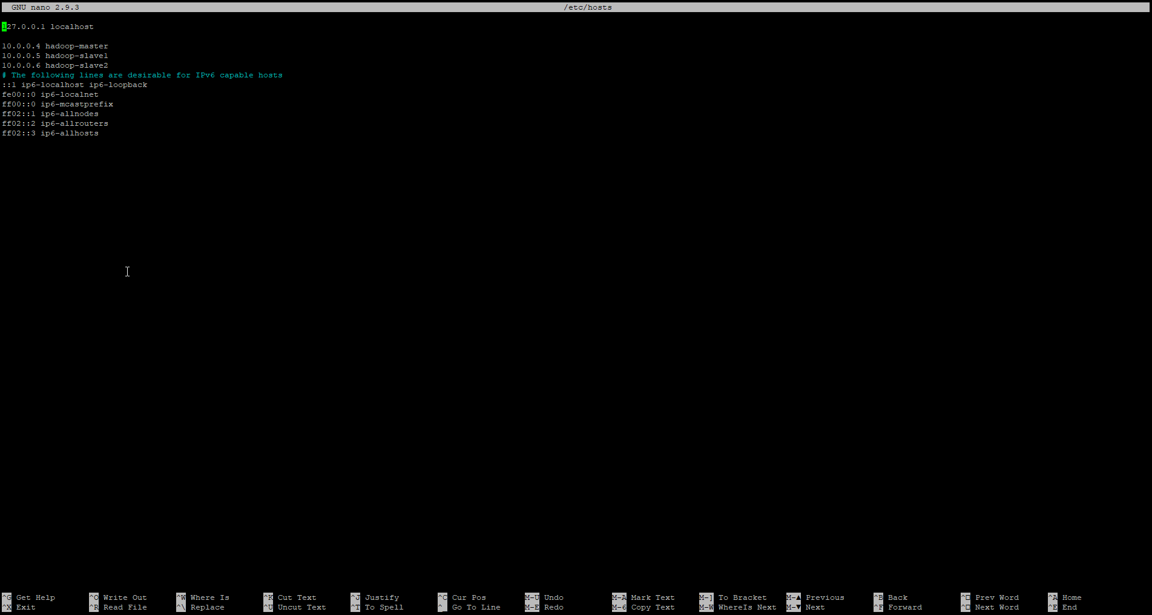**Slave 2 –** 10.0.0.6

**Data Nodes (Screenshot 1)**

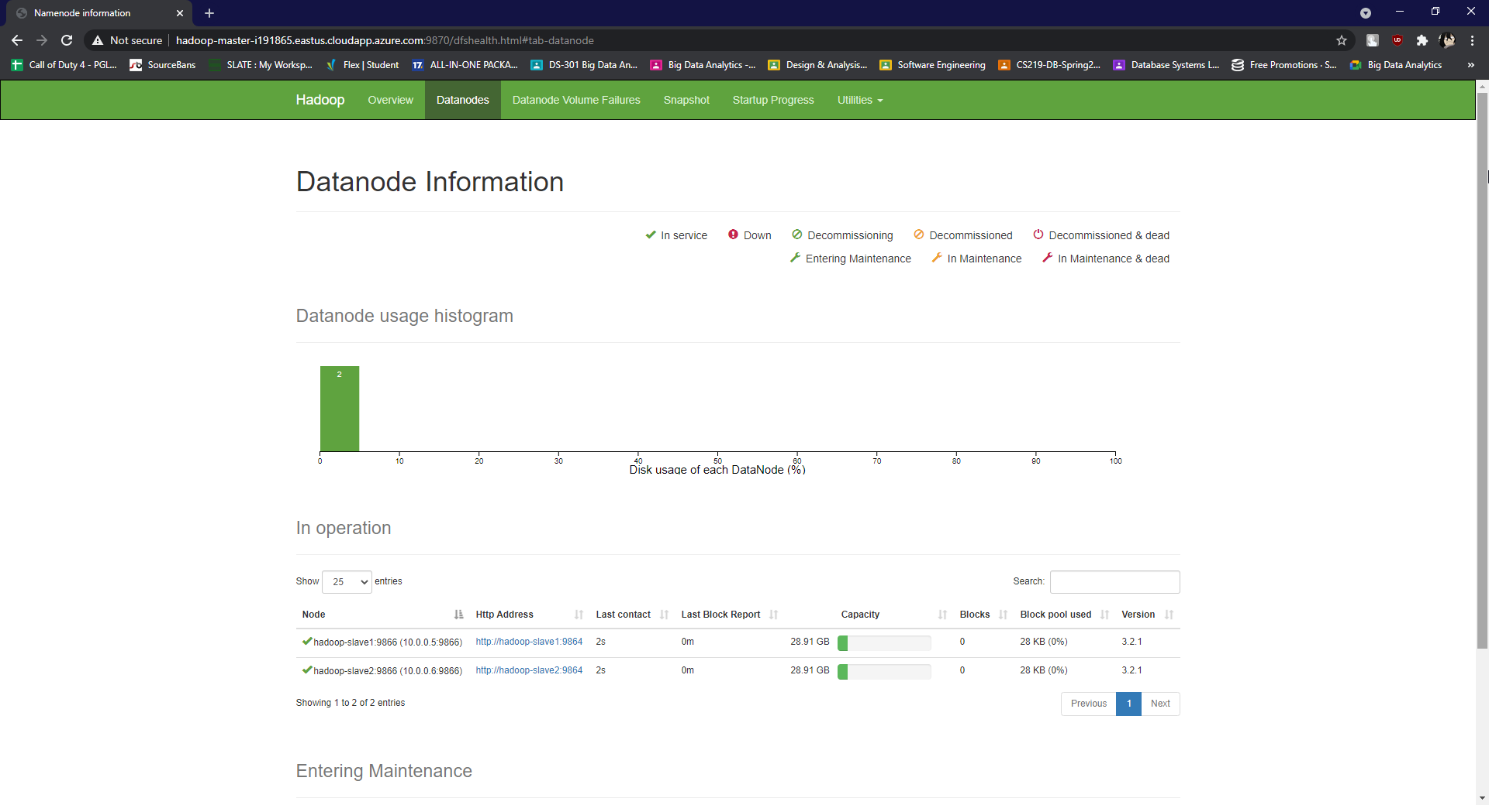

**Node States (Screenshot 2)**

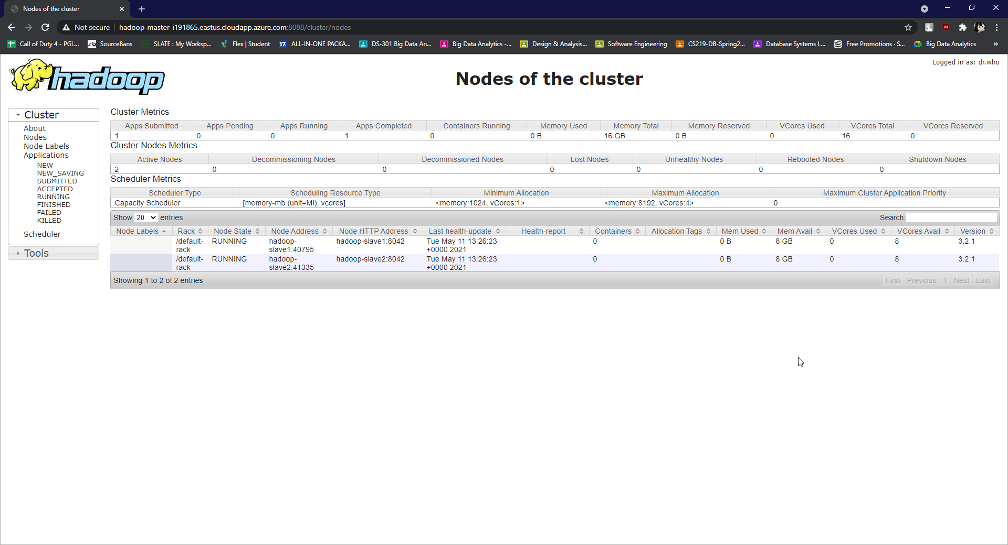

**Success – Output (Screenshot 3)**

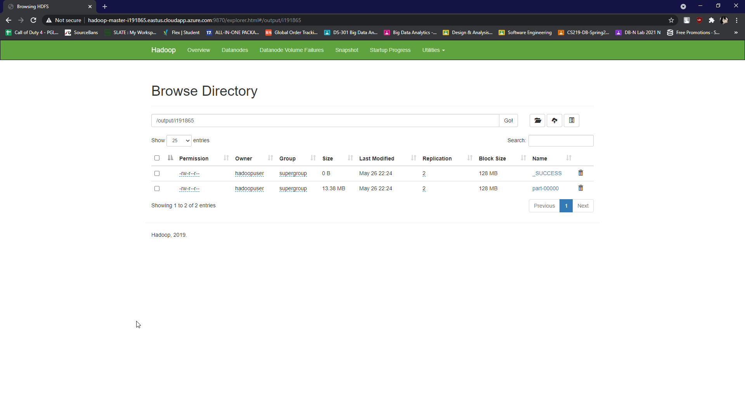

**Cluster Overview (Screenshot 4)**

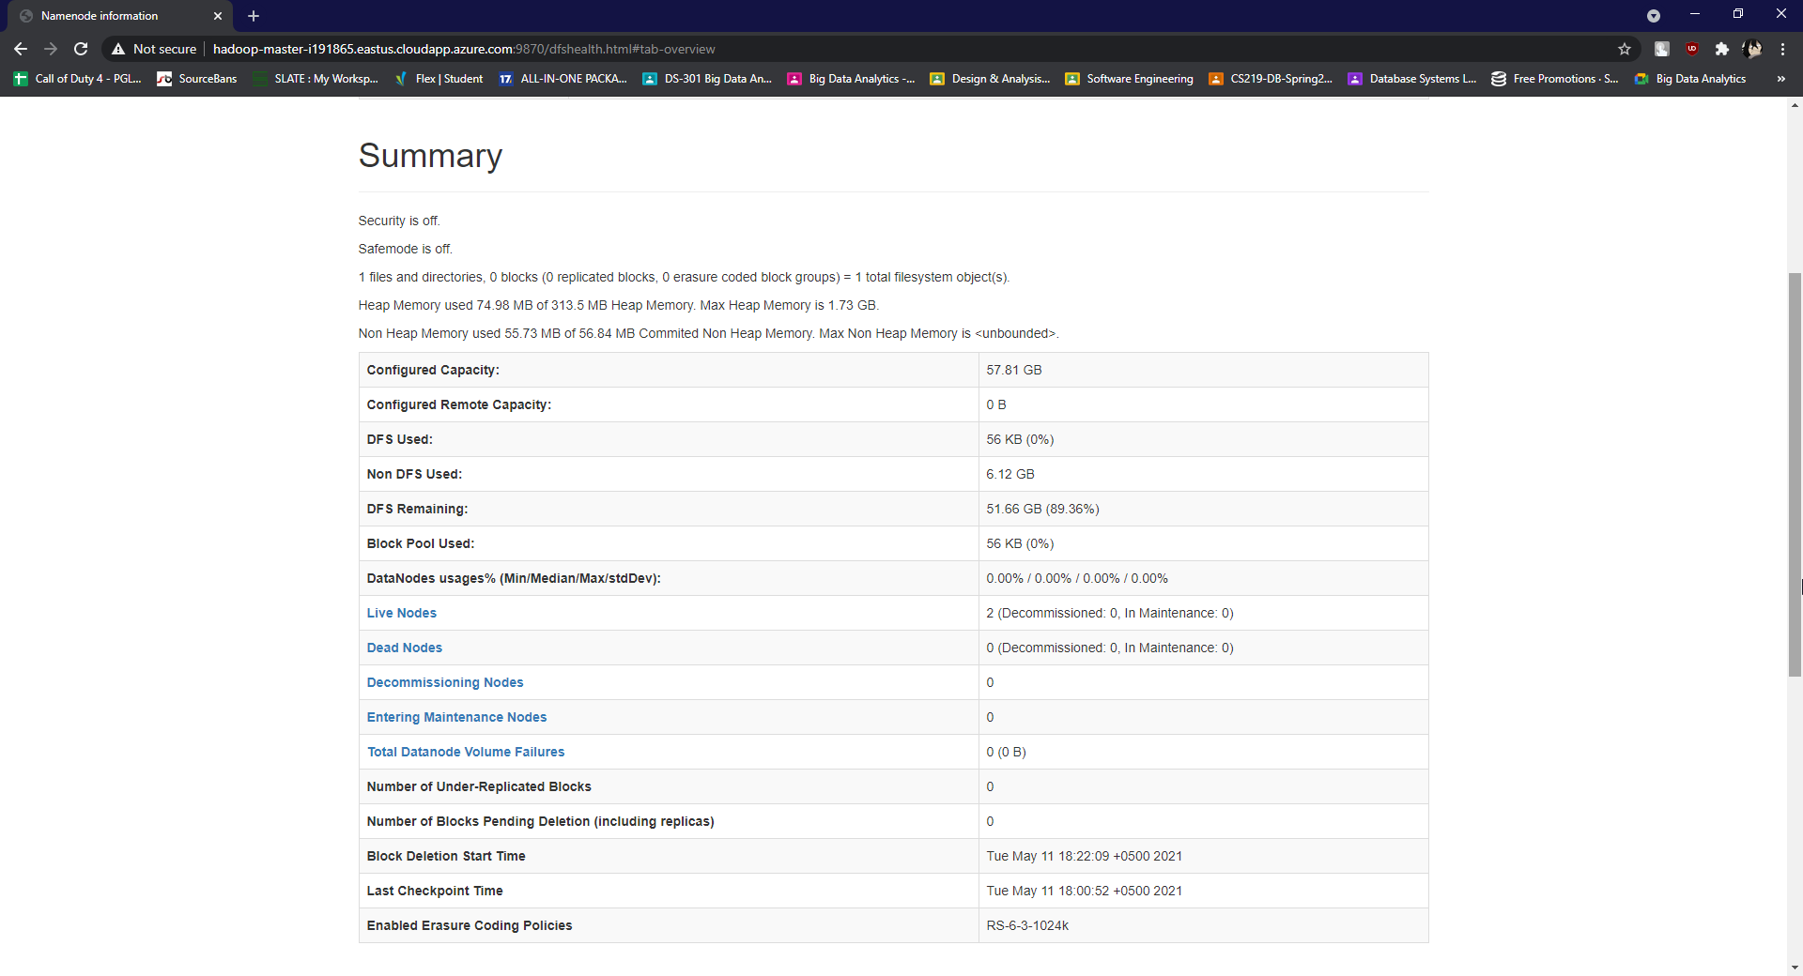

**View Output (Screenshot 5)**

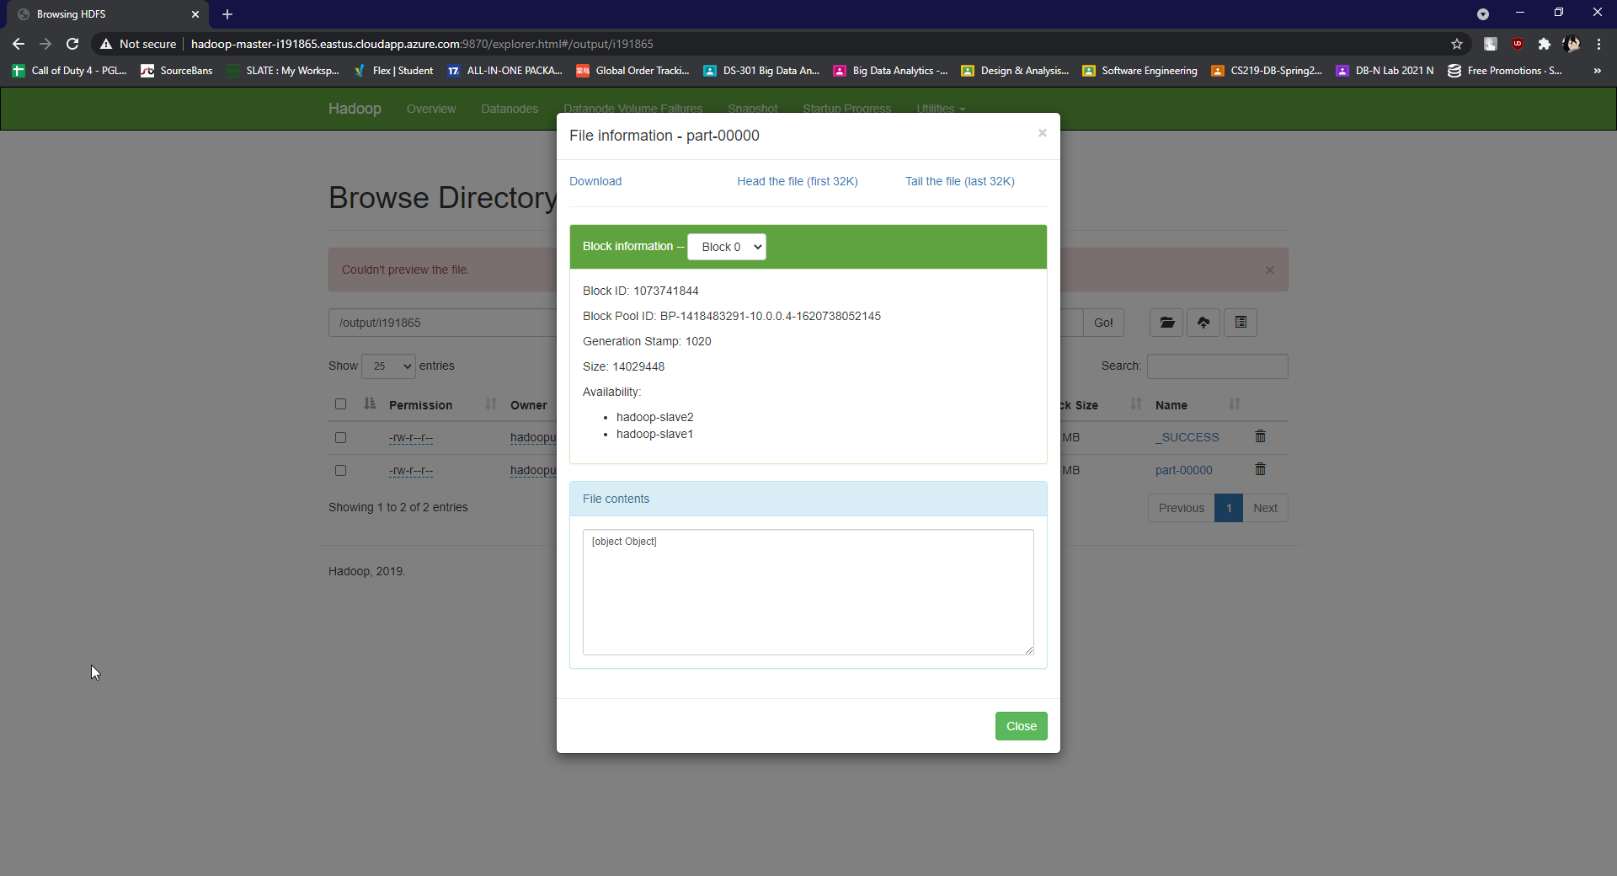

**Cat Output (Screenshot 6)**

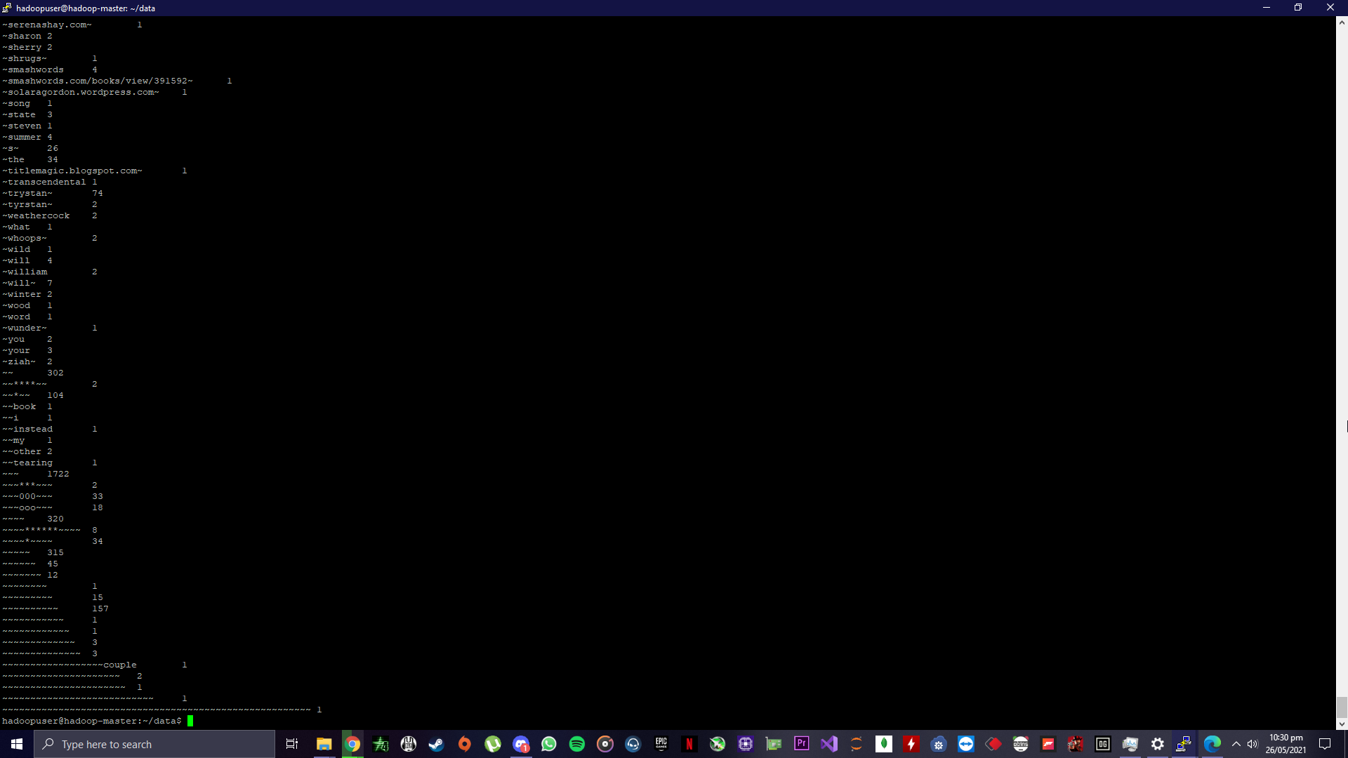

**VM View (Screenshot 7)**

